A message from the PTA

A big thank you to those who attended the PTA AGM on 25 September. It was lovely to see you all in person and a great way to kick off the year.

We are delighted that Anoushka Roberts (Jimmy Y5 and Hamish Y3) will be this year's PTA Chair. Sarah Wallace (Dora Reception and Arthur Y2) will remain as Treasurer with Sian Kelly (Luka Y3) as Co-Treasurer and Claire Collins (Theo Y3 and Evelyn Y4) as Secretary.

Our thanks to outgoing Chair Susie Hall for doing such a fantastic job.

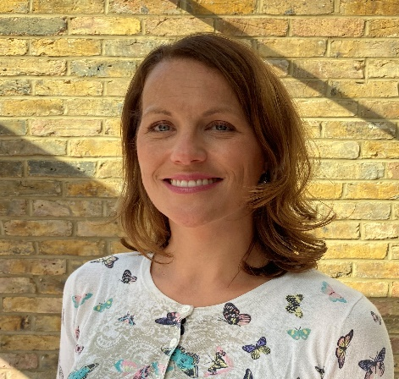
A message from our new Chair of the PTA

Hello St Jude’s Families, Teachers & Friends,

I wanted to say how delighted I am to be taking on the role of Chair of the PTA and continuing to drive the much-needed fundraising for additional things that the school needs. The PTA is a great team and I’ve got the wonderful support of Sarah & Sian (Co-Treasurers) and Claire (Secretary).

We all know that school funding is limited and that is why the PTA is so vitally important to buy all the extras our children deserve to have to enhance their education and enjoyment at school. In the past the PTA has raised money for laptops, interactive whiteboards, the Key stage 1 playground, school trips and workshops amongst other things. We are also giving half of the funding towards a new green screen to go around the Key Stage 2 playground to absorb pollution and keep our children safe.

This year because of Covid-19, we need your help with fundraising more than ever. We haven’t been able to do our 3 biggest events, the Summer Fair, Fun Run and Christmas Fair so need to be creative about raising funds through other means. We have some great ideas for Christmas events including raffles, an Advent challenge and an online gift shop. Please get in touch if you have any thoughts or would like to be involved. You can email the PTA at stjudespta@gmail.com

St Jude’s is such a wonderful school and I feel lucky and proud to be a part of it.

Hope to see you all soon,
Anoushka

